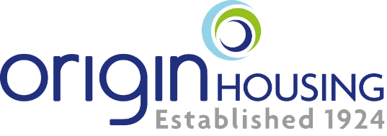

Community Fund Application
Up to £2000

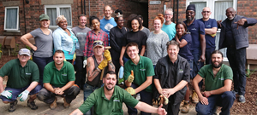

The Community Fund provides people with the opportunity to turn their own ideas or
vision into reality for the primary benefit of Origin residents. Simply complete this application form and submit via email to community.development@orignhousing.org.uk.

If you are a bit overwhelmed by the information required, or want to discuss your idea, please call us on 0300 323 0325 and ask for the Community Development Team who will be happy to help and discuss your project. Also see our Community Fund information video https://youtu.be/5PYk2xIa8Ok

- ABOUT APPLICANT

Name of Organisation/group:

Main Contact Person:

Address:

Contact number:

Email address:

How did you hear about Origins Community Fund?

Please tell us the main aims and objectives of your organisation/group (max1250 characters)

- PROPOSED PROJECT

Project name: Funding requested:

Please provide a brief description of the project (Max 1250)

Please detail any specific activities you will undertake. For example, we will work with local residents for four separate sessions (Max 1250 characters)
Please explain the need/demand for your project (Max 1250 characters)
Please evidence the demand for the project below. You should use a range of sources e.g. consultations with individuals or groups interested in the project, recent research, official statistics, current service demand (Max 1250 characters)
How will you make this project accessible to Origin residents?

Estimate the number of people who will benefit from the project below.
Location of project delivery our project needs to be no more than 1 mile away from Origin homes. Do you meet this requirement? Yes/No

Please indicate location from our areas below and include post code of location for example: Camden NW1 1BS.

Camden  Enfield  Barnet  Brent  Islington  Harrow  Hackney  Haringey  Tower Hamlets | Stevenage  Watford  Hertsmere  North Hertfordshire  Welwyn Hatfield  Three Rivers  Other_____________(Detail
We are particularly keen to receive applications that support our investing in communities’ priorities below as part of our Together strategy or tackle the impact of COVID-19. Please tick which of the following themes your project meets
- Supporting families
- Increase financial resilience
- Race and equality
- Employment and skills development
- Support physical and mental wellbeing
- Investment in community safety – climate change or others
Please detail how your project will meet the above themes (Max 1500 characters)
How long will it take to complete the proposed project?

Start date: |  | Completion date:
Will you work with others to deliver the project? If so, please detail who and how you will work together. (Max 1250 characters)
Outline the key risks associated with the project and how you will minimise their impact (Max 1250 characters) For example, identify potential hazards, the risk of someone being harmed and what you will do to reduce the risk.
How will we know if the project has been a success? Use this space to outline how you will measure the impact of the project, e.g. feedback forms, interviews or online surveys (Max 1250)
3. PROJECT COSTS

How much will the project cost? Estimate based on quotes is allowed (Quotes must be submitted with the application form) |  |  | £
Project expenditure (please provide a breakdown of costs for delivering the project below)

Description of expenditure |  |  | Cost £
Total raised through other sources of finance. List of funding organisations:  -  -  - |  |  | Value (£)
Funding in kind (non-cash contribution to your project that is provided free of charge) Please list below:  -  -  - |  |  | Value (£)

REFERENCE
Please provide details of a referee that we can contact to support your application. (Please ensure this person is an independent third party)
Name:
Name of Organisation they work for (organisations only):
Contact number:
Email:
Relation to you/ organisation:
Please use the checklist below to check that you have all the supporting evidence required for your project?
- Reference details completed (All)
- Public liability insurance (if required)
- Statement evidencing that all staff and practitioners are DBS checked to the required standards for the project being undertaken (if you plan to work with children & other vulnerable groups).
- Risk Assessment (in line with government guidelines)
- Quotation to support listed expenditures on the application (All)

- DECLARATION
I confirm that the information given on this form and any supporting papers is to the best of my knowledge and belief true and accurate. I understand that if I have given misleading information this will be sufficient grounds for cancelling this application.

By submitting this form, you indicate your consent Origin Housing Ltd using material contained in this application, or in any accompanying documentation, for publicity purposes.

Origin Housing take your privacy and security seriously and will only process your personal data for the purposes stated in this form and in line with the General Data Protection Regulation (GDPR).

If your application for funding is unsuccessful, the data included in this application form will be retained for one year.

If your application for funding is successful, the data included in this application form will be retained for three years with the exception of your name, email address and the name of the organisation for whom you have made this application which will be retained permanently so we may contact you regarding progress of the funded project.

Signature:
Date:

